**Perhatikan topologi di bawah ini!**

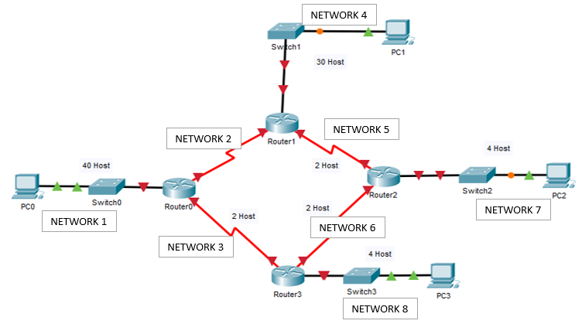

**Gambar 1. Topologi Jaringan**

**SOAL**

Sebuah perusahaan mempunyai hirarki topologi jaringan sesuai pada gambar 1, dimana alamat IP yang menghubungkan jaringan tersebut adalah **200.20.3.0/24.**

Dari deskripsi jaringan perusahaan tersebut kerjakanlah soal-soal berikut :

1. Tentukan pembagian alamat IP address (subnet VLSM) dari masing-masing subnet pada jaringan perusahaan tersebut, kemudian lengkapilah tabel berikut.
2. Konfigurasilah alamat IP tiap interface pada masing-masing router pada tabel, sesuai dari hasil pembagian subnet yang telah dikerjakan pada soal 1
3. Implementasikan hasil pembagian IP *address* anda sebelumnya pada topologi jaringan di atas dengan **metode *dynamic routing*** untuk menghubungkan tiap jaringan.
4. Pada router R1, R2, R3, dan R4 konfigurasikan untuk:
5. Memberi hostname
6. R1 : LABORAN
7. R2 : DOSEN
8. R3 : MAHASISWA
9. R4 : HIMA
10. Melakukan disable DNS lookup.
11. Memberikan EXEC mode password.
12. Menggunakan kata “**tubes0403**” utk secret password,
13. Memberikan password bagi koneksi console (**PrakJarkom**).
14. Memberikan password untuk koneksi telnet (**PrakJarkom**).
15. Memasukkan IP Address pada setiap interface router.
16. Pada R1, R2, R3 dan R4 Konfigurasikan *Dynamic Routing*

**KETERANGAN:**

1. Untuk PC gunakan ***last valid*** IP
2. Untuk *Router* gunakan ***first valid*** IP

**CATATAN:**

*VLSM* merupakan metode yang memberikan *Network Address* lebih dari 1 *subnetmask*, berbeda dengan *CIDR* yang hanya memiliki 1 subnetmask saja. ***VLSM* memiliki manfaat untuk mengurangi jumlah alamat yang terbuang.**

Langkah-Langkah VLSM:

1. Menghitung kebutuhan host dari tiap jaringan
2. Urutkan jaringan dari host yang paling besar sampai dengan host yang terkecil
3. Hitung jumlah range IP dan prefixnya.

|  |  |  |  |  |  |  |  |
| --- | --- | --- | --- | --- | --- | --- | --- |
| **2**7 | **2**6 | **2**5 | **2**4 | **2**3 | **2**2 | **2**1 | **2**0 |
| ***128*** | ***64*** | ***32*** | ***16*** | ***8*** | ***4*** | ***2*** | ***1*** |







**JAWABAN:**

1. Pembagian Alamat IP *Address*

|  |  |  |  |
| --- | --- | --- | --- |
| **Nework 1** | | **Nework 2** | |
| Σ IP diperlukan | 30 | Σ IP diperlukan | 2 |
| Σ IP disiapkan | 32 | Σ IP disiapkan | 4 |
| Prefix | /27 | Prefix | /30 |
| Alamat Jaringan | 202.20.122.0 | Alamat Jaringan | 202.20.122.80 |
| IP Valid Range | 202.20.122.1- 202.20.122.30 | IP Valid Range | 202.20.122.81- 202.20.122.82 |
| Alamat Broadcast | 200.20.3.31 | Alamat Broadcast | 202.20.122.83 |
| **Nework 3** | | **Nework 4** | |
| Σ IP diperlukan | 2 | Σ IP diperlukan | 20 |
| Σ IP disiapkan | 4 | Σ IP disiapkan | 32 |
| Prefix | /30 | Prefix | /27 |
| Alamat Jaringan | 202.20.122.84 | Alamat Jaringan | 202.20.122.32 |
| IP Valid Range | 202.20.122.85– 202.20.122.86 | IP Valid Range | 202.20.122.33 – 202.20.122.62 |
| Alamat Broadcast | 202.20.122.87 | Alamat Broadcast | 202.20.122.63 |
| **Nework 5** | | **Nework 6** | |
| Σ IP diperlukan | 2 | Σ IP diperlukan | 2 |
| Σ IP disiapkan | 4 | Σ IP disiapkan | 4 |
| Prefix | /30 | Prefix | /30 |
| Alamat Jaringan | 202.20.122.88 | Alamat Jaringan | 202.20.122.92 |
| IP Valid Range | 202.20.122.89 – 202.20.122.90 | IP Valid Range | 202.20.122.93 – 202.20.122.94 |
| Alamat Broadcast | 202.20.122.91 | Alamat Broadcast | 202.20.122.95 |
| **Nework 7** | | **Nework 8** | |
| Σ IP diperlukan | 4 | Σ IP diperlukan | 4 |
| Σ IP disiapkan | 8 | Σ IP disiapkan | 8 |
| Prefix | /29 | Prefix | /29 |
| Alamat Jaringan | 202.20.122.64 | Alamat Jaringan | 202.20.122.72 |
| IP Valid Range | 202.20.122.65 – 202.20.122.70 | IP Valid Range | 202.20.122.73 – 202.20.122.78 |
| Alamat Broadcast | 202.20.122.71 | Alamat Broadcast | 202.20.122.79 |

1. Konfigurasi IP Interface tiap-tiap Router

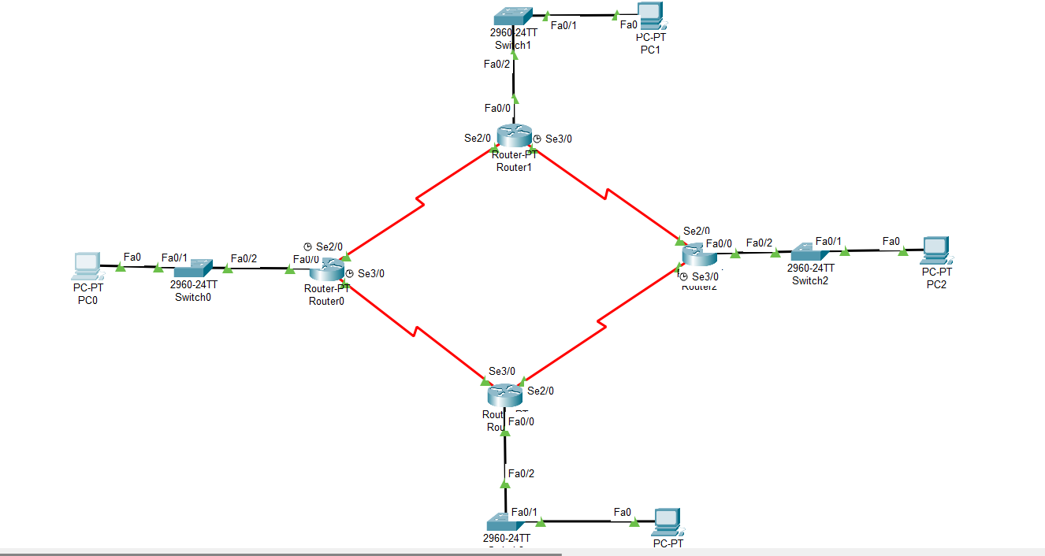

|  |  |  |  |  |
| --- | --- | --- | --- | --- |
| **Device** | **Interface** | **IP Address** | **Subnet Mask** | **Default Gateway** |
| R0 | Fa0/0 | 202.20.122.1 | 255.255.255.224 | N/A |
| Se2/0 | 202.20.122.81 | 255.255.255.252 | N/A |
| Se3/0 | 202.20.122.85 | 255.255.255.252 | N/A |
| R1 | Fa0/0 | 202.20.122.65 | 255.255.255.224 | N/A |
| Se2/0 | 202.20.122.82 | 255.255.255.252 | N/A |
| Se3/0 | 202.20.122.89 | 255.255.255.252 | N/A |
| R2 | Fa0/0 | 202.20.122.65 | 225.255.255.248 | N/A |
| Se2/0 | 202.20.122.90 | 255.255.255.252 | N/A |
| Se3/0 | 202.20.122.93 | 255.255.255.252 | N/A |
| R3 | Fa0/0 | 202.20.122.73 | 225.255.255.248 | N/A |
| Se2/0 | 202.20.122.93 | 255.255.255.252 | N/A |
| Se3/0 | 202.20.122.85 | 255.255.255.252 | N/A |
| PC0 | NIC | 202.20.122.30 | 255.255.255.224 | 202.20.122.1 |
| PC1 | NIC | 202.20.122.62 | 255.255.255.224 | 202.20.122.33 |
| PC2 | NIC | 202.20.122.70 | 225.255.255.248 | 202.20.122.65 |
| PC3 | NIC | 202.20.122.78 | 225.255.255.248 | 202.20.122.73 |

NETWORK 8

1. Konfigurasi *Dynamic* dan *Static Routing* Pada Setiap Router1

| **Device** | **Konfigurasi *Static Routing*** | **Device** | **Konfigurasi *Dynamic Routing*** |
| --- | --- | --- | --- |
|
| R0 | 202.20.122.32/27 via 202.20.122.82 | R2 | Route eigrp 20 |
|  | 202.20.122.92 |
|  | 202.20.122.64 |
|  |  |
|  |  |
| R1 | 202.20.122.0/27 via 202.20.122.81 | R3 | Route eigrp 20 |
|  | 202.20.122.72 |
|  | 202.20.122.92 |
|  |  |
|  |  |

1. Konfigurasi *Static* dan *Dynamic Routing* apakah yang Anda gunakan pada topologi di atas? mengapa Anda menggunakan konfigurasi tersebut? **Jelaskan sedetail – detailnya**!

_____________________________________________________________________________________________________________________________________________________________________________________________________________________________________________________________________________________________________________________________________________________________________________________________________________________________________________________________________________________________________________________________________________________________________________________________________________________________________________________________________________________________________________________________________________________________________________________________________________________________________